**Daniel Jones**

**Rice Data Analytics Bootcamp**

**Unit 1 HW Kickstart My Chart.QA**

**6/14/2019**

**Given the provided data, what are three conclusions we can draw about Kickstarter campaigns?**

1. As the Goal amount increased the % of Failed projects tended to increase and the % of Successful projects tended to decrease, the % of Cancelled projects also tended to increase as the Goal amount increased
2. Projects with Goal amounts less than $1,000 seem to have had the highest success % in relation to all projects
3. The highest number of Successful projects started in May

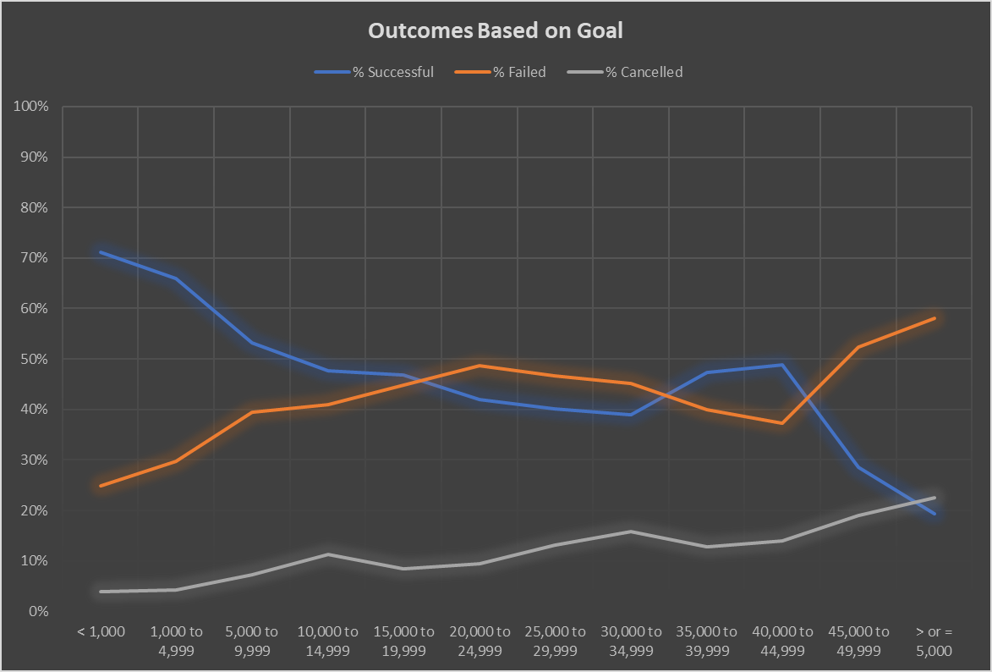

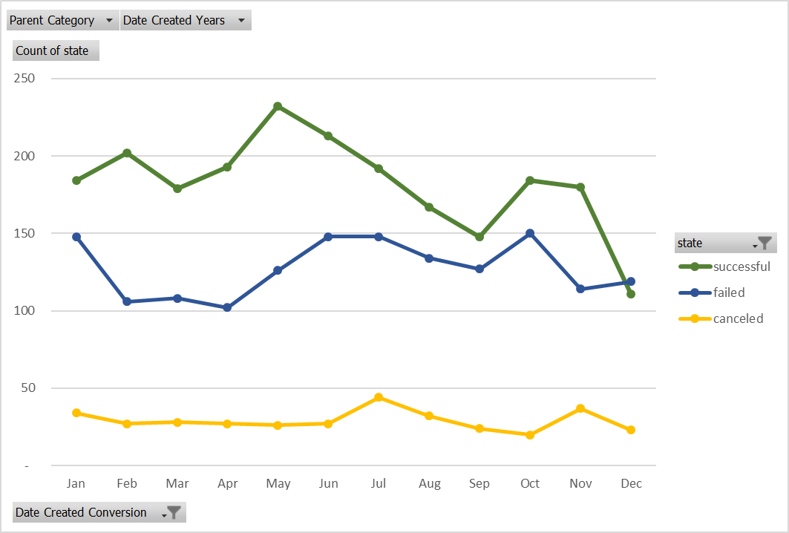

**What are some limitations of this dataset?**

* There are multiple currencies.
  + While not a huge limitation, to appropriately compare metrics that take into consideration goal and/or pledged amounts, currency values should be converted into all the same currency, such as USD. The exchange rates used would have to be for the specific relevant time period, e.g. April 2011 vs April 2017.
* Don’t know if backers are family members of project originator

**What are some other possible tables and/or graphs that we could create?**

* A table or graph that analyzed success, failure, and cancelled projects based on country of origin
* An analysis, line graph, of the length of campaign (difference between launch date and end date) and the success % and the failure %